HEALTHMAX | FMCG ANALYTICS DIVISION
FMCG Market Analysis &
Net Revenue Management
Strategic Analysis Report | Shampoo Category

Prepared by: Satvik Sharma
Data Analyst & Category Manager
FY 2023

Executive Summary
HealthMax is the current market leader in the highly competitive FMCG shampoo category. This report synthesizes external retailer data with internal financials, applying Net Revenue Management (NRM) principles across pricing, promotions, and product mix to deliver clear strategic recommendations for revenue and profit maximization.

$140.96M  Total Market (MAT Mar 2023)  Shampoo Category | 68.5%  Portfolio Gross Margin  Highly efficient | +25.91%  HealthMax YoY Growth 2022  Peak growth year | 1,161%  Best Promo ROI  Buy 2 Get 1 Free

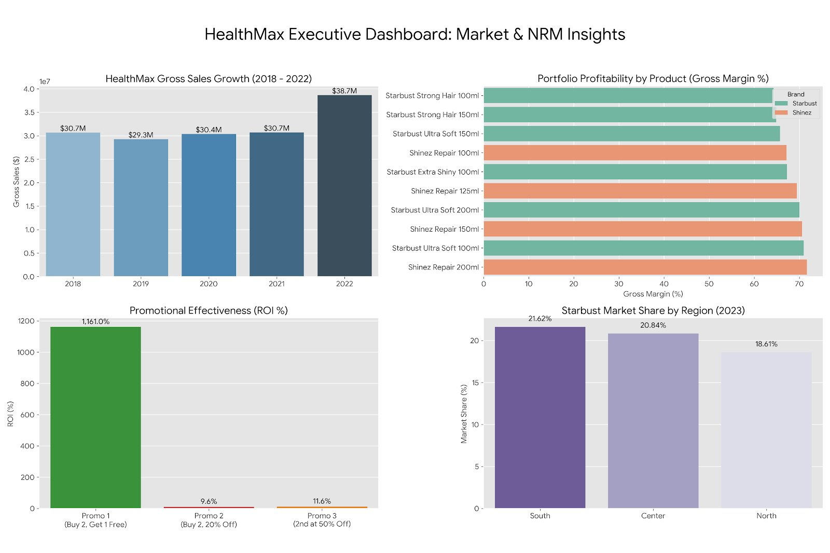
Figure 7: HealthMax Executive Dashboard — Market & NRM Insights

1. Business Context & Objective
Our Position: HealthMax is the current market leader in the competitive shampoo category.
The Challenge: In a high-volume, low-margin FMCG environment, maintaining market leadership requires constant optimization. We analyzed external retailer data alongside internal financials to uncover strategic growth opportunities.
The Objective: Apply Net Revenue Management (NRM) principles to evaluate pricing, promotions, and product mix — ultimately delivering actionable recommendations to maximize Net Sales and Gross Profit.

2. Data Gathering & Integration
To build a holistic view of the market, we synthesized four key data streams:

Data Source | Description
External Retailer Data | 4,400+ records tracking competitor & HealthMax sales (Units & Value) across multiple regions, 2018–2023
Internal Sales Data | Proprietary financials: Net Price, Retail Price, COGS, and 2022 unit volumes for Shinez & Starbust brands
Promotion Analysis | Campaign costs and sales data for three major promotional mechanisms executed for the Shinez brand
New Product Launch Data | Estimated market share and production costs for two pipeline products: HerbEssentials & Herbashine

3. Methodology & Calculations
- Data Cleansing: Standardized European number formats and reconciled missing decimal values in pricing/COGS data for financial accuracy.
- Time-Series KPIs: Engineered dynamic Excel models using SUMIFS to calculate YTD and Moving Annual Total (MAT) metrics — stripping seasonality to track true performance.
- Profitability Modeling: Calculated Net Sales, Total Gross Profit, and Gross Margins at the SKU level.
- Promotional ROI: Modeled baseline sales by averaging pre- and post-promo months to isolate pure revenue uplift and calculate campaign ROI.

4. Key Findings & Strategic Insights

A. Overall Market Performance
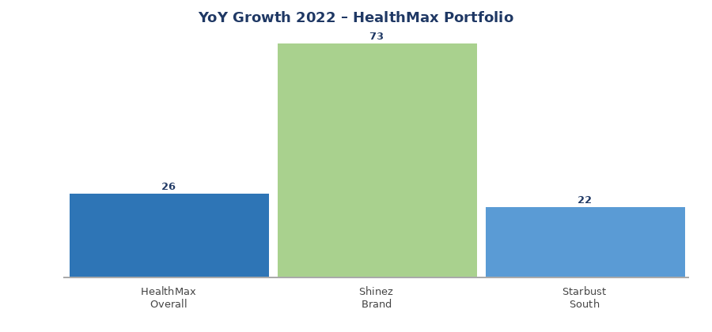
Figure 1: HealthMax YoY Growth — Portfolio vs Shinez Brand (2022)
Peak Growth: HealthMax achieved its strongest YoY growth in 2022, surging by 25.91%, driven by the Shinez brand (+73% YoY).
Category Valuation: Total market turnover for the shampoo category (MAT as of March 2023): $140.96 Million.
Regional Strengths: Starbust brand holds its strongest market share position in the South Region (21.62%).

B. Competitor Strategy — The FreshCo Opportunity
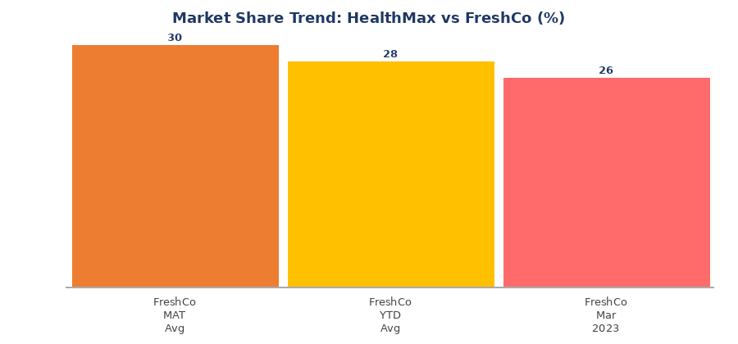
Figure 2: FreshCo Industries — Market Share Erosion After Shifting to Digital-Only Strategy
Insight: FreshCo Industries recently shifted their entire marketing budget from TV to digital advertising.
Impact: Their market share dropped from a 12-month MAT average of 30% → 28% YTD average → 26% low in March 2023.
⚠ Recommendation: Do NOT follow FreshCo into a digital-only strategy. Maintain our omnichannel presence to capture the market share they are actively losing.

C. Portfolio Profitability (NRM)
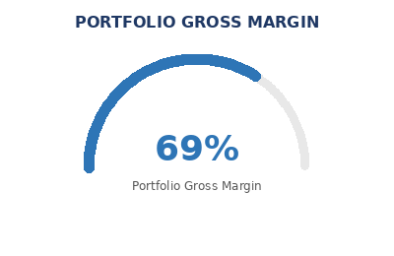
Figure 3: HealthMax Portfolio Gross Margin
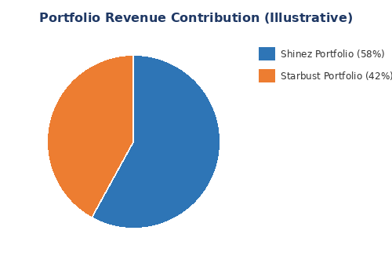
Figure 4: Illustrative Revenue Mix — Shinez vs Starbust
The HealthMax portfolio demonstrates exceptional financial efficiency:
Metric | Detail
Portfolio Gross Margin | 68.5% — industry-leading efficiency
Total Gross Profit (2022) | Over $14 Million
Volume Champion | Starbust Ultra Soft 100ML — 1.15M units (critical for market penetration)
Profit Engine (Hidden Gem) | Shinez Repair 200ML — 71.67% GM, $4.30 Gross Profit per unit (highest in portfolio)

D. Promotional Effectiveness
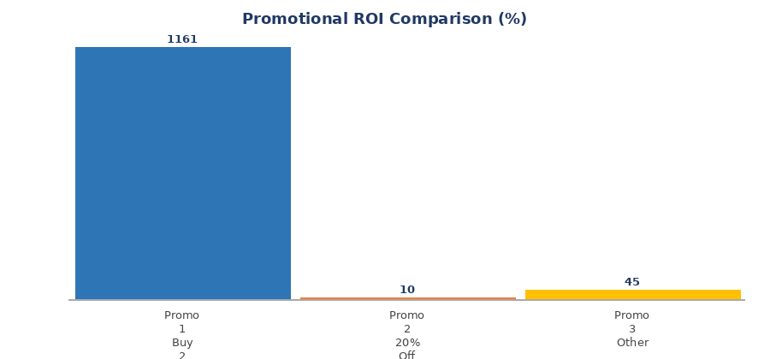
Figure 5: ROI Comparison Across Three Promotional Mechanics — Shinez Brand
Three promotional mechanics were evaluated for the Shinez brand:

Promotion Mechanic | Performance
Promo 1 — Buy 2, Get 1 Free | ✓ 1,161% ROI | $7.8M+ in pure revenue uplift | RECOMMENDED
Promo 2 — 20% Off | ✗ < 10% ROI | Deep discounting erodes margin
Promo 3 — Other Mechanic | ~45% ROI | Moderate performance
✓ Recommendation: Future trade spend should aggressively prioritize Promotion 1 (Buy 2, Get 1 Free). Avoid deep discount mechanics that compress margins.

E. New Product Launch Recommendation
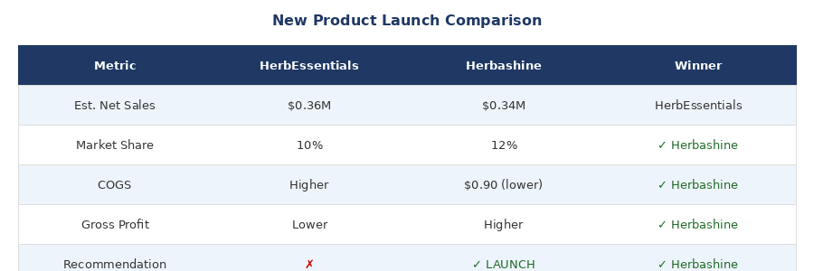
Figure 6: HerbEssentials vs Herbashine — Head-to-Head Comparison
✓ Launch Herbashine. While HerbEssentials projects slightly higher topline Net Sales ($0.36M vs $0.34M), Herbashine commands a higher estimated market share (12% vs 10%), lower COGS ($0.90), and delivers stronger overall Gross Profit — fully aligned with our NRM objective of maximizing profit, not just revenue.

5. Next Steps for Management
Action | Description
1 | Approve the Herbashine launch roadmap and allocate production/marketing resources.
2 | Reallocate Q3/Q4 promotional budgets specifically toward 'Buy X, Get Y' mechanics, supported by the Shinez historical ROI data.
3 | Protect the Shinez Repair 200ML supply chain — it disproportionately supports the portfolio's bottom-line profitability.

HealthMax | Prepared by Satvik Sharma, Data Analyst & Category Manager | FY 2023

